**HOTEL EMRALD**

**HOME PAGE**

Presentation Layer:

* In the navbar of Home page there will be a login it consists of admin section and receptionist section.
* In the same navbar one contact also there and that comprises of important contacts of the Hotel employees
* Right below the navbar there will be a slideshow
* In the body part of main page will display of some suave pictures regarding Hotel views

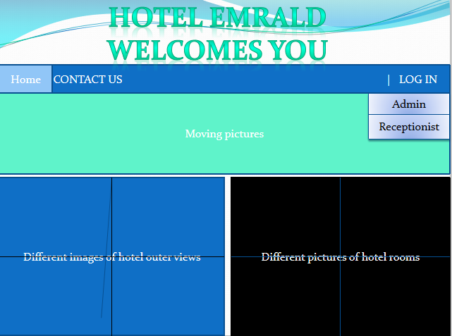

**ADMIN:**

Presentation Layer:For admin login: we have to click the admin in the navbar it will redirect to the login page of admin, there we have to put the correct login credentials of admin.

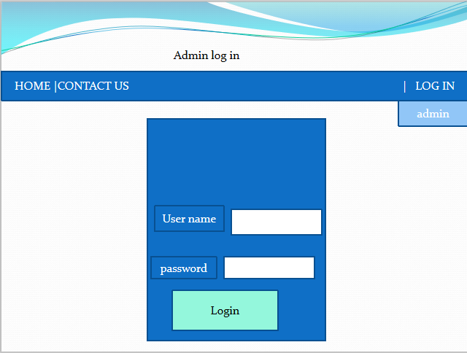

* After the successful login the admin main page will occur and that page consists of some options like Employee info ,add employee, Rooms info , Add room(elaborating further)

*Employee info*

It will consist of all employees who are presently working in Hotel.

And in each and every record there will be buttons like delete (it will delete the record of that particular employee)and update(for further updation in future)

*Add Employee*

It is basically for the hiring new employee purpose, after clicking that it will redirect to the form and there we fill the whole form regarding to the personal info of that particular employee and in the bottom will click to the add button it will add the employee to the database.

*Room info:*

In this section there will be the statuses of Rooms basically its for checking purpose weather its occupied or not.

*Add room:*

Here we will adding new rooms in respect of type.

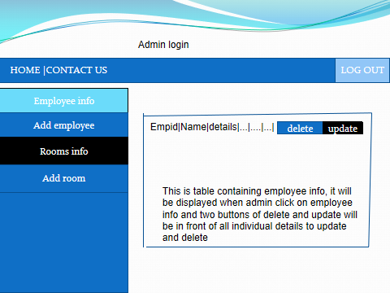

Service Layer:

Dao Layer:

**RECEPTION SECTION**

**Presentation Layer**

* In the main Home page we have login section (admin part explained above) we have reception part Here the receptionist will book the rooms according to the preference of the guests.
* Firstly the receptionist will check the availability of the rooms, and according to the convenience he or she will suggest.

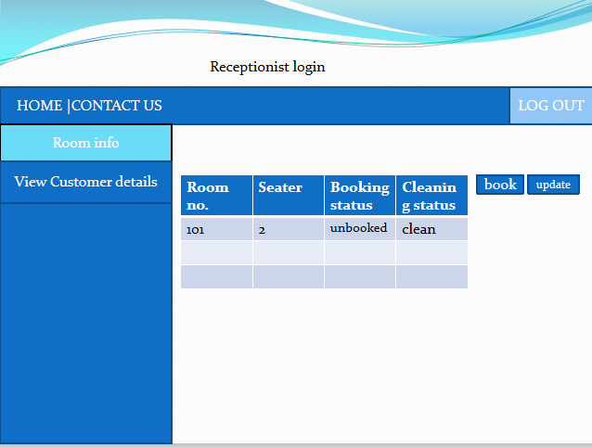

*Room info:*

* In the section of room info there will be the booked status and as per guest’s choice if that room if vacant will book it.
* After clicking the book button , the customer adding form page will occur and there the receptionist will fill personal info of guests.
* After Filling the whole for in the bottom One Add button will be there after clicking that the whole info will store into the database.

*View Customer details:*

Here the it will consist the personal information of Guests who are presently stay in the hotel.

